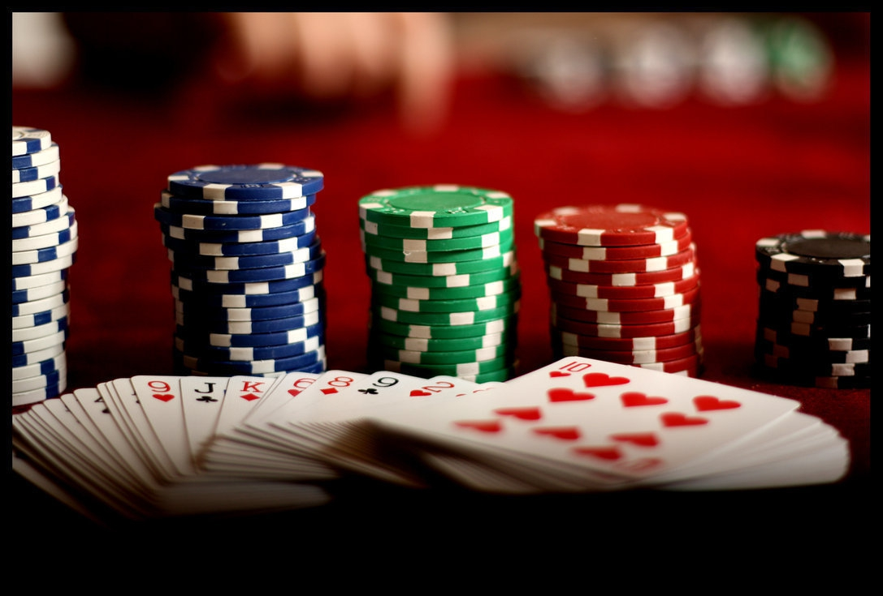

Casino Night
Bishop Montgomery High School Fundraiser
Double up your winnings, and upsize your fun.
You’ll enjoy great music, heavy hors d oeuvres, a hosted bar and fun prizes. If you don’t gamble, come to eat, drink and dance to a live band
Don’t miss your chance to hit the jackpot.
Saturday, November 9th, 2019
Brookdale South Bay (Across From BMHS)
5:00 to 9:00 p.m.

$30.00 Entry Fee pre-sale $35.00 at the door
Beer, Wine, and Hosted bar. Free Valet Parking
RSVP Today Mr. Marafino: amarafino@bmhs-la.org 310.540.2021x246 Amy 310.540.2021 x 249
Jeanne Hagmaier Jhagmaier@brookdale.com

