Welcome to the Spanish/English Book Club
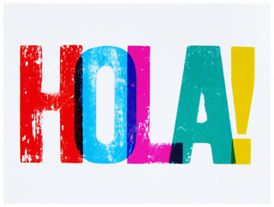
First meeting will be held on Tuesday, July 25, 2023 at 10:00 a.m.
And after the first meeting we will be meeting regularly the second Tuesday of every month at 10:00 a.m. All meetings will be held at the Bartlett Senior Center 1318 Cravens Avenue.
Victoria Spiegel will be the group moderator
 For more information, please call the Bartlett Senior Center at (310) 320-5918

