Do Good With
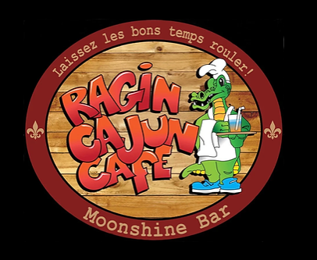

20% of your check will be donated to the Torrance Rose Float Association to help build the 2025 float!
WHAT: DINE-IN or TAKE-OUT
WHEN: THURSDAY, AUGUST 28, 2024
TIME: FROM 11:30 A.M. – 9:00 P.M.
WHERE: 531 N Pacific Coast Hwy, Redondo Beach / (310) 376-1066
Thank you for your generosity.

