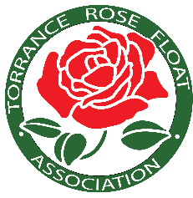
Please join our community
Restaurants for Roses fundraiser at

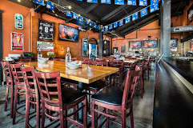
The Torrance Tavern
22735 Hawthorne Blvd., Torrance
Wednesday, August 14th, 2024
11 AM - Midnight

Enjoy an amazing food item from their menu or just an alcoholic drink at the bar. As long as you present a copy of this flyer to your server, Torrance Tavern will donate a generous 20% of your trip to TRFA. All proceeds will help to build our 2025 float.

Take Out and Online Orders Included!!
Thanks for your support!

